03 HBase
HBase Overview
- HBase is a column based distributed storage system that feature high reliability, performance and scalability
- HBase is suitable for storing big table data which can contain billions of rows and millions of columns, and allow real-time data access
- HBase uses zookeeper for its collaboration service
HBase vs relational database
HBase differs from the traditional relational databases in the following aspects
- Data indexing:
  - a relational database can build multiple complex indexes for different columns to improve data access performance. HBase has only one index: the row key. All access methods in HBase can be accessed using the row key or row key scanning, which ensure that systems run properly
- Data maintenance
  - During updates in relational databases, the most recent value replaces the original value in the record. The original value no longer exists after being overwritten. When an update is performed in HBase, a new version is generated, and the original one is retained
- Scalability
  - It is difficult to horizontally expand relational databases, and the space of vertical expansion is limited. In contrast, distributed databases – such as HBase and Big Table – are developed to implement flexible horizontal expansion. Their performance can easily be scaled by adding or reducing the hardware in a cluster

Use Cases of HBase
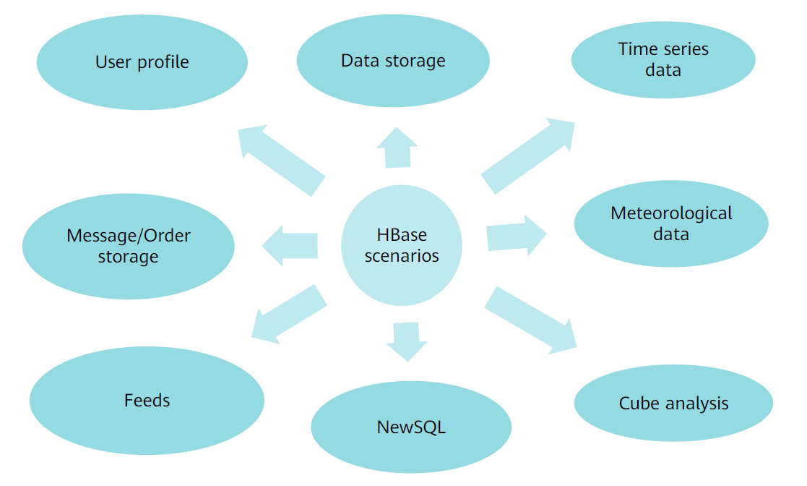
HBase Data Model
- Applications store data in HBase as tables. A Table consists of rows and columns. All columns belong to a column family
- The table structure is sparse. The intersection of rows and columns is called cell, and cells are versioned. The content of a cell is an inseparable byte array
- A rowkey of a table is also a byte array, so anything can be saved, whether it is a string or number
- All tables must have a primary key. HBase tables are stored by the key, and the sorting made is based on byte
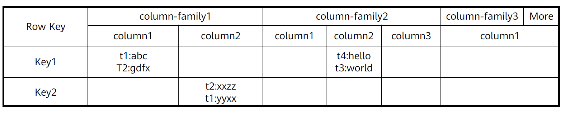

HBase Table Structure
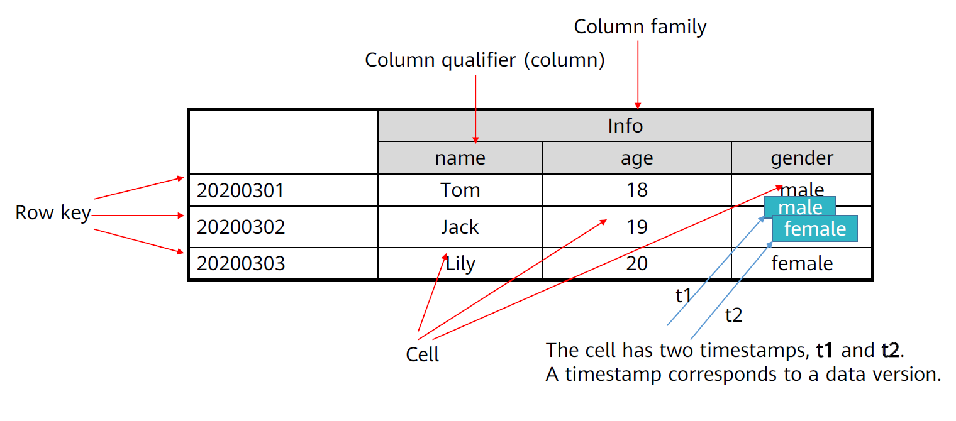
- Table
  - HBase uses table to organize data. A table consists of rows and columns, and a column is divided into several column families
- Row
  - Each HBase table consists of multiple rows, with each row identified by a row key
- Column Family
  - An HBase table is divided into multiple column families, which are basic access control unit
- Column Qualifier
  - Data in a column family is located using column qualifiers (or columns)
- Cell
  - In an HBase table, a cell has no type and is viewed as a byte array – byte []
- Timestamp
  - Each cell stores multiple versions of the same data. These versions are indexed using timestamp
Conceptual View of Data Storage

